ACTIVITY 6-5 TN

IS IT CONSISTENT?

Teacher Notes

Fingerprint Identification and Matching
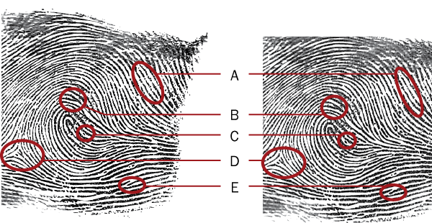

All photos © Cengage Learning

- Identify each of the patterns labeled in the ridge pattern diagram. Refer to the chart on minutiae in the text.

A. Short ridge

B. Bifurcation

C. Island

D. Delta

E. Ridge ending

- Examine each of the fingerprints below. Using a red pen and referring to Figure 6-9 in your text, circle the minutiae pattern and then label it with the appropriate number.
All photos © Cengage Learning

Arthur

1. Bifurcation

2. Island ridge
3. Ridge ending

Doris

4. Eye

5. Spur or hook
6. Ridge ending

Alice

7. Double bifurcation
8. Island ridge

Suspect

What patterns can you find in this print?
Island

Island ridge

Bifurcation

